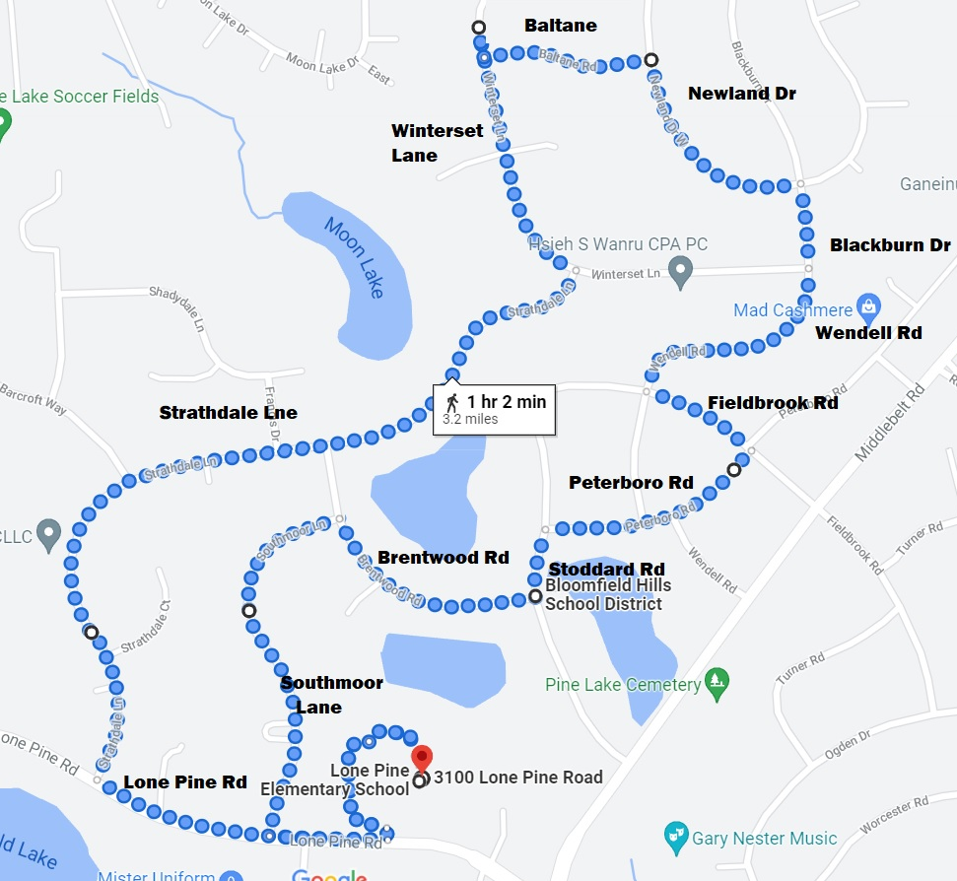
LONE PINE ELEMENTARY SCHOOL 3.2 MILE WALK

Meet at Upper Parking Lot
(Lone Pine Elementary, 3100 Lone Pine Rd.)
Leave the parking lot and head West on Lone Pine Rd.
Turn right (North) on Strathdale Lane (go past Southmoor Lane).
Left (North) on Winterset Lane.
Right on Baltane.
Right on Newland Dr.
Right (South) on Blackburn Dr that turns into Wendell Rd.
Left (East) on Fieldbrook Rd
Right on Peterboro Rd
Left on Stoddard Rd
Right on Brentwood Rd
Left on Southmoor Lane
Left on Lone Pine Road back to Upper parking lot

